FRONT LINE ARMORY Agreement of Terms and Release from Liability
I, the Customer, acknowledge and accept all of the terms and conditions set forth below.
Estimated turn around time: I will never, under any circumstances, give a promised completion date on any project. If you need a project by a certain date the best I can do is give a good faith estimate, ahead of time. But again, I make NO promises. I will provide an estimated turn around time based on current work load and volume of work currently being handled. Current situation is all I can honestly gauge a projected time line on. It is VERY IMPORTANT that you understand that this turn around estimated time can change dramatically due to the circumstances relating to business and personal situations. All work of same or similar type will be processed in order. Small work (non build+refinish work) WILL always be started ahead of larger jobs and turns around at a much faster rate than the larger projects. I reserve the right to accept only the work I wish to complete as well as the right to return, unfinished, any work I can not complete or do not wish to complete.
Updates: I will provide periodic updates on your project. These will usually be when I have performed some actual work but will also try and update as to general status, particularly if turn around times are changing (for better or worse). Feel free to email in an inquiry if you have not heard from me in a while Such as in excess of 4 weeks. I do not consider asking for an update to be "bugging me". I prefer email due to the record I can refer to later and the fact that it can be handled when I have time during the day. The phone is not as reliable since I may not answer it while working. If you ask me to complete a project by a certain date it I will try to accommodate. Please do not demand I complete a project by a certain date. I can not and will not do work out of order. If you have waited longer than you wish to, I will return your project unfinished with appropriate refund. No hard feelings. I will not finish projects ahead of other work or ahead of MY abilities to complete the project to my quality standards.
Parts & labor: All parts needed for work must be supplied by customer or paid for in advance of work being performed. No exceptions. Labor costs do not need to be remitted up front, but customers are free to pay in advance. Completed projects will not ship until all costs are paid for. Any parts that are needed to be added to an existing project but not known until after work is started due to oversight –OR- needed as a result of changes to the work made after work arrives, will be invoiced and total will need to be remitted before item ships back to customer. Labor amount is determined from listed rates or direct quote for work not specifically listed.
Insurance: My insurance does not cover loss of your firearms or parts due to theft, flood or other act of nature, war, OR ANY OTHER REASON.. Most insurance companies that insure firearms will cover the items while they are away at a gunsmith. Check to make sure YOUR insurance (NRA or other) does this and that you have ample insurance coverage for the item(s) sent.
Payment: Parts (those needed at time of work request) must be paid for in advance or supplied, unless otherwise and specifically stated in your quote that I supply. Labor, shipping and all final costs per the final invoice I will supply will be paid in full before projects are returned. Again, I do not require payment up front for labor, only parts. Customers are free to pay in advance at their choosing. Payments accepted: Cash, check and Money Order
Shipping: All firearms are shipped with "Adult signature required". No exceptions. All firearms can only be returned to the original owner or an FFL licensee. No exceptions. Rifles: I prefer to ship rifles via UPS ground or express. Customer is responsible for paying the actual return shipping charges. I do not charge for packaging. Handguns: I will only ship Handguns via UPS overnight or "overnight saver" to non licensees. I will, on request, ship handguns via USPS Priority Mail, insured, restricted delivery to an FFL holder. NFA Items: I will only return ship NFA (class III) items via UPS Overnight or second day air. NO EXCEPTIONS. This is the only sensible way to ship these valuable items. I do not require a form 5 transfer to work on NFA items (the ATF does not require this) If you want a form 5 transfer to accompany your NFA item to my shop and back there will be a fee to cover the paperwork processing. Please contact me for details.
Personal delivery and pickups: This is by appointment only and must be arranged ahead of time. All visitors are hereby given the following NOTICE: FLA shop premises are monitored by both video and audio recording.

Assumption of Risk: I, the Customer, acknowledge that I have voluntarily requested of FRONT LINE ARMORY, activities with include, but which is not limited to, modifications and alterations to a gun which may affect various safety systems. I am aware that alterations and modifications of guns may be hazardous. I am voluntarily requesting that these activities take place with the knowledge of the dangers involved which include death, dismemberment and paralysis, and I hereby agree to accept any and all risks or injury or death and verifiy this statement by placing my signature on this contract.

Signature:___________________________________________ Date:__________________
The legal fine print:
• As consideration for this gunsmithing being performed pursuant to my direction, I hereby agree that I, my assignees, heirs, distributees, guardians an d legal representatives, will not make a claim against, sue or attach the property of FRONT LINE ARMORY, or any of its affiliated organizations, for injuries or damages resulting from negligence or other acts how so ever caused by FRONT LINE ARMORY, or any employee, agent or contractor of FRONT LINE ARMORY, or any of it affiliated organizations as a result from my request for modification or alteration to a gun.
• I hereby release FRONT LINE ARMORY and any of its affiliated organizations from all actions, claims or demands that I, my assignees, heirs, distributees, guardians or legal representatives now have or may hereafter have for injuries or damages resulting from my request of modification or alteration to a gun set forth in this Work Order.
• The Customer is informed, realizes and understands that any alterations which the Customer has requested to be done to the Customer's gun, pursuant to the Work Order, may release the Manufacturer from any liability for any accident should any occur.
• The Customer recognizes, realizes, and by reading and signing the Work Order, understands that by the Customer's request that these changes occur, that he is also releasing the Gunsmith, both individually and in any business form, from any liability should any accident occur because of the requested changes or alterations.
• The Customer will indemnify and defend the Gunsmith from all liability for any loss, damage or injury to persons or property arising from or related to the performance of the agreement including, without limitation, all consequential damages whether or not resulting from the negligence of the Customer or Customer's agent.
• This agreement supercedes any and all other agreements either oral or in writing, between the Customer and the Gunsmith with respect to the subject of this contract. This contract contains all of the covenants and agreements between the parties with respect to the gunsmithing work pursuant to the Work Order and each party to this contract acknowledges that no representations, inducements, promises or agreements have been made by or on behalf of any party, except those covenants and agreements embodied in this contract. No Agreement, statement or promise not contained in this contract shall be binding or valid.
• The validity of this agreement and any of its terms or provisions, as well as the rights and duties of the parties under this agreement, shall be construed pursuant to and in accordance with the laws of the State of Pennsylvania.
• If any term of this agreement is held by a court of competent jurisdiction to be void or unenforceable, the remainder of the contract terms shall remain in full force and effect and shall not b e affected.
• Unless other arrangements are made, in writing, any jobs left in the shop for more than 60 days after written notification of job completion and request for payment of balance will be considered abandoned and may be sold to cover expenses.
• We guarantee our work for 30 days on the job as described in the work order labor only. Since parts may be from new or used origin, FRONT LINE ARMORY does not guarantee any parts. New parts may or may not carry a manufacturer’s warranty.
• Parts orders return policy: All returns are at the discretion of FRONT LINE ARMORY.
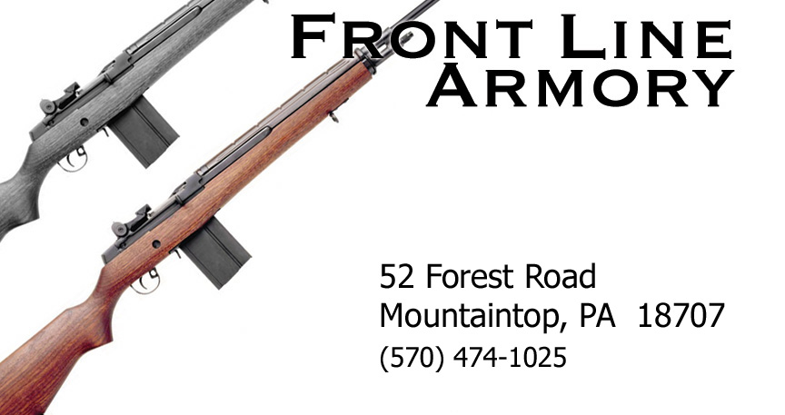

Work Order

Full Name: |  | Date Shipped:
Shipping Address: |  | Firearm Make:
Home Phone: |  | Firearm Model:
Other Phone:  (Optional) |  | Estimated / Quoted cost  (if known)  From received estimate or price list | $
(Optional) ………..…….
Description of work requested:

